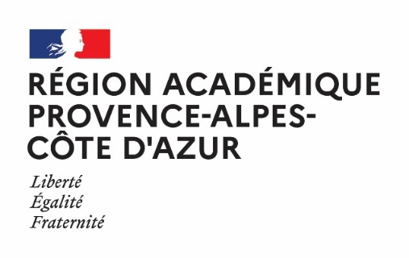

RECHERCHE D’UN PARTENAIRE
PARTNER RESEARCH
A retourner à / Return to: ce.drareic@region-academique-paca.fr

Date de la demande : 25/08/2022
Application date : …/…/……

ÉTABLISSEMENT DEMANDEUR – APPLICANT SCHOOL
NOM - NAME | INSTITUT ESCOLA LONDRES
STATUT (PUBLIC / PRIVÉ)  STATUS (PUBLIC / PRIVATE) | PUBLIC
PAYS - COUNTRY | SPAIN
ADRESSE - ADRESS | C/ COMTE D’URGELL, 262  08036 BARCELONA
MAIL | ielondres@xtec.cat
TÉLÉPHONE - PHONE | (34) 93 439 48 00
NOM ET ADRESSE MAIL DU CHEF D’ÉTABLISSEMENT / DIRECTEUR  NAME AND MAIL OF SCHOOL HEAD | Mrs. SUSANA NARANJO  e-mail: snaranjo@ielondres.cat
CARACTÉRISTIQUES DE L’ÉTABLISSEMENT  CHARACTERISTICS OF THE SCHOOL | - Situation géographique – Geografic location :  □ RURAL - RURAL x□ URBAIN - URBAN  - Nombre total d’élèves – Total number of students : 550  - Langues enseignées – Languages taught: Catalan, Spanish, English, French, German.  - Internat – Boarding school :  □ OUI - YES x□ NON - NO

CARACTERISTIQUES DU PARTENARIAT – CHARACTERISTICS OF THE PARTERSHIP
PERSONNE CONTACT + MAIL  CONTACT PERSON + EMAIL | Mrs. NURIA VILA  e-mail: nvila@ielondres.cat
MATIÈRES IMPLIQUÉES  SUBJECTS INVOLVED | Languages
ÂGE DES ÉLÈVES CONCERNÉS PAR LE PARTENARIAT  AGE OF STUDENTS CONCERNED BY THE PARTNERSHIP | 12 to 16
PERIODICITE DES ECHANGES POTENTIELS (ATTENTION AU CALENDRIER SCOLAIRE)  WHEN WOULD POTENTIAL EXCHANGE TAKE PLACE (BE CAREFUL NOT TO INCLUDE HOLIDAYS) | Short-term exchanges (from 5 to 7 days, at least once a year). Being careful to the French school-year calendar and adapting to the best choice for the hosting school.
CENTRES D’INTÉRÊT POUVANT SERVIR DE BASE AU PARTENARIAT  AREAS OF INTEREST THAT COULD BE USED AS A BASIS FOR THE PARTENERSHIP | □ Théâtre – Drama  X□ Arts plastiques – Fine arts  □ Musique – Music  □ Histoire/géographie – History and geography  □ Médias et actualités – Media and news  □ Europe – Europe  X□ Développement durable – Sustainable development  X□ Patrimoines locaux – Local heritage  X□ Comparaisons interculturelles – Intercultural comparisons  □ Cuisine locale – Local cooking  □ Sport – Sport  □ Spécialités professionnelles – Profesionnal speciality  □ Citoyenneté – Citizenship  □ Numérique/Technologie – Digital technologies  □ Autres (à préciser) – others :
PERSPECTIVES DU PARTENARIAT  THE PARTNERSHIP OUTLOOK | - eTwinning :  □ OUI - YES □ NON – NO  - Échanges de classes – School exchanges:  X□ OUI - YES □ NON – NO  - Mobilité du personnel – Staff mobility:  □ OUI - YES □ NON – NO  - Stages en entreprise à l’étranger – work experience abroad  □ OUI - YES □ NON – NO  - Erasmus+ projets:  □ OUI - YES □ NON - NO
PROFIL DE L’ETABLISSEMENT RECHERCHÉ - PROFILE REQUIRED
DESCRIPTION DE VOTRE RECHERCHE – DESCRIBE WHAT YOU ARE LOOKING FOR

We would like to find a school in which our students at Secondary stage, that is,12-16 year-old and who have decided to learn French as a second foreign language could have the valuable opportunity to experience a short-term exchange in France with all the advantages of an intense linguistic and cultural immersion.
Moreover, we are open to design a specific project/programme with the French school that could fulfill the expectations of both schools. We have long experience in the Erasmus Programme and we would like to welcome French students in Barcelona, as well, to improve their Spanish or English.
Our objective is to give answer to our students’ request of improving their learning languages processes and to settle down a solid partnership with a French school. Thanks for your consideration.

